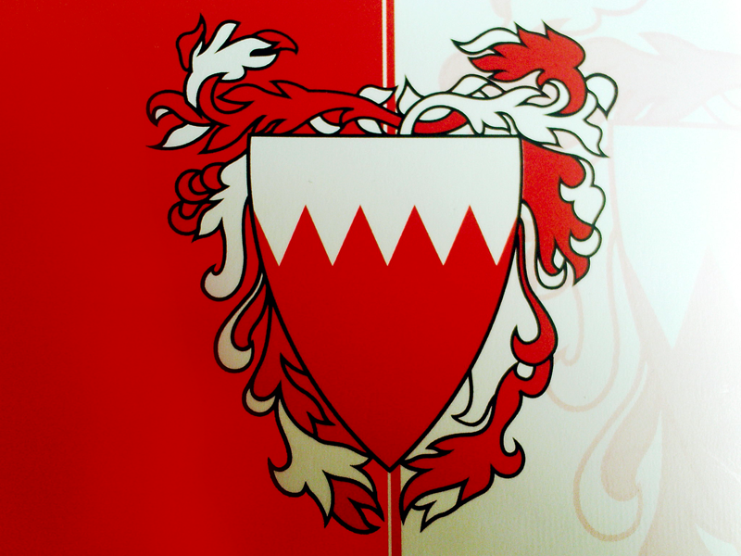
Ahmed Khalid Al Janahi
Mrs.Timm
12 E
May 14, 2013
Bahrain Poem
Bahrain is the place I was born inside
It is the land of people with peace
Houses here are held by women insight
Everyone here should follow the rules of police
We have the best cultural food in the world
The most delicious rice with chicken
Whatever your taste in food we have it fivefold
We are surrounded by water from all sides
The five pillars of Islam is our flag
In summer you will be surrounded with pride
I am proud to be a Bahraini
It’s the land of my friends and family
It is a small place that makes the world shiny

